Simplified Diffusion Model (DDPM)
Deep Learning with Python — Chapter 17 Assignment
Pure NumPy implementation · 3-layer MLP · T = 100 timesteps

1. What is a Diffusion Model?
A diffusion model learns to generate images by learning to reverse a noise process. Training has two stages:
- Forward process: take a real image and slowly add Gaussian noise over T steps until it becomes pure random noise.
- Reverse process: train a neural network to undo one step of noise at a time, so we can start from pure noise and produce a realistic image.

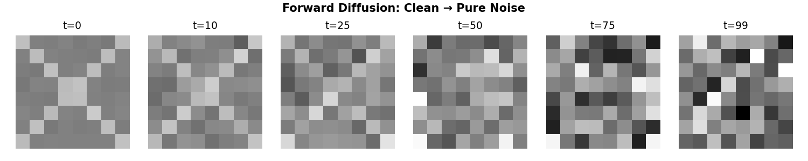
Figure 1 — Forward process: a clean pattern is gradually destroyed by noise (t = 0 → 99)

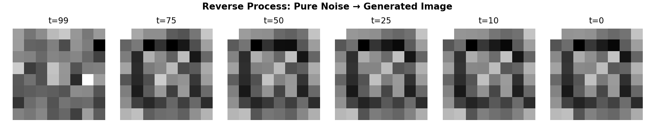
Figure 2 — Reverse process: the trained model denoises from pure noise back to a pattern (t = 99 → 0)

2. Model Architecture
Instead of a complex U-Net (Chapter 17), this model uses a simple 3-layer MLP (Multi-Layer Perceptron). The network takes a noisy image and a time step as input, and outputs the predicted noise.

Layer | Input | Output | What it does
Time Embedding | t (scalar) | 32 | Encodes the timestep as a 32-dim sinusoidal vector
Concatenate | 64 + 32 | 96 | Join noisy image pixels and time vector together
Linear + ReLU | 96 | 128 | First hidden layer, learns basic features
Linear + ReLU | 128 | 128 | Second hidden layer, deeper features
Linear (output) | 128 | 64 | Predicted noise — same shape as the input image
Total trainable parameters: 37,120 (vs ~100 million in U-Net)

Time Conditioning
The model needs to know which timestep it is working at, because early steps remove big coarse noise while late steps handle fine detail. We encode t as a fixed sinusoidal vector (the same idea as positional encoding in Transformers):
e(t) = [ sin(t·f₁), sin(t·f₂), … , cos(t·f₁), cos(t·f₂), … ] → 32 numbers

3. Noise Schedule
The cosine schedule controls how much noise is added at each timestep. It is smoother than the linear schedule used in the original paper, so the model has more signal to learn from at each step.
ᾱₜ = cos²( (t/T + 0.008) / 1.008 · π/2 ) βₜ = 1 − ᾱₜ / ᾱₜ₋₁
At t=0: ᾱ ≈ 1, almost no noise. At t=99: ᾱ ≈ 0, almost pure noise.

4. Loss Function
The model is trained to predict the noise ε that was added to the image. The loss is simply the mean squared error between the predicted noise and the actual noise:
Loss = MSE( ε̂, ε ) = E [ ‖ ε − εθ(xₜ, t) ‖² ]
This is easy to compute and works well in practice. At each training step: pick a random image, a random timestep, add noise, predict the noise, compute MSE, backpropagate.

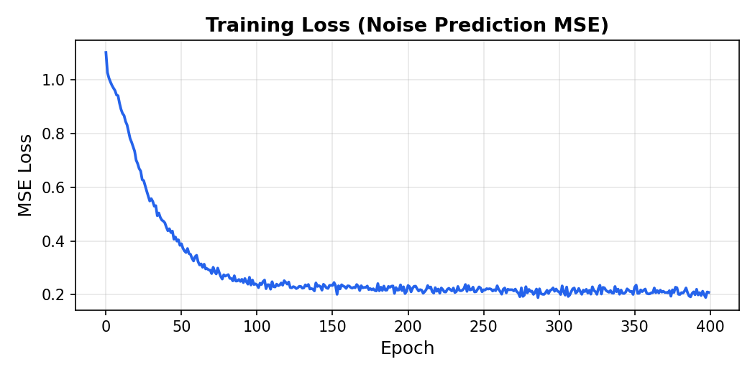
Figure 3 — Training loss over 400 epochs. Final MSE: 0.209

5. Generated Samples
After training, we generate new images by starting from pure Gaussian noise and running the reverse process for 100 steps. Each step the model removes a bit of noise until a pattern emerges.

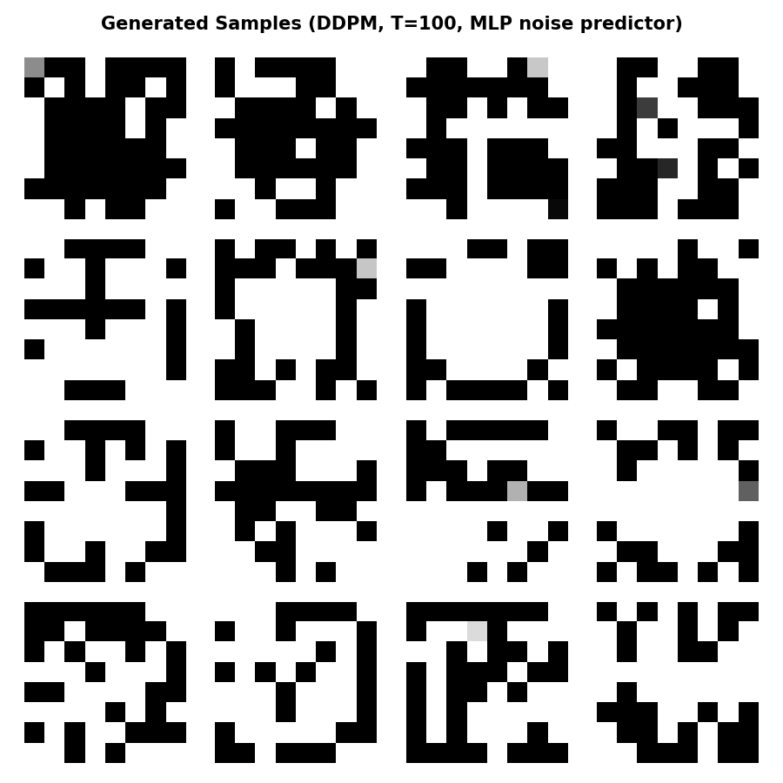
Figure 4 — 16 images generated by running the full reverse chain from pure noise

6. Comparison to Chapter 17
 | Chapter 17 (U-Net) | This model (MLP)
Network | U-Net with attention & skip connections | 3-layer MLP
Parameters | ~100 million | 37,120
Image size | 64×64 RGB (CelebA faces) | 8×8 grayscale patterns
Timesteps | T = 1000 (linear) | T = 100 (cosine)
Framework | Keras / TensorFlow | Pure NumPy
Loss | MSE noise prediction | MSE noise prediction ✓ same
Training time | Hours on GPU | ~30 seconds on CPU

The math is identical. The only difference is the neural network in the middle: U-Net is powerful enough for real photos; MLP is enough to understand how diffusion works.

References: Ho et al. (2020) DDPM · Nichol & Dhariwal (2021) Improved DDPM · Chollet (2023) Deep Learning with Python Ch. 17

